CS 255 System Design Document Template

UML Diagrams

UML Use Case Diagram
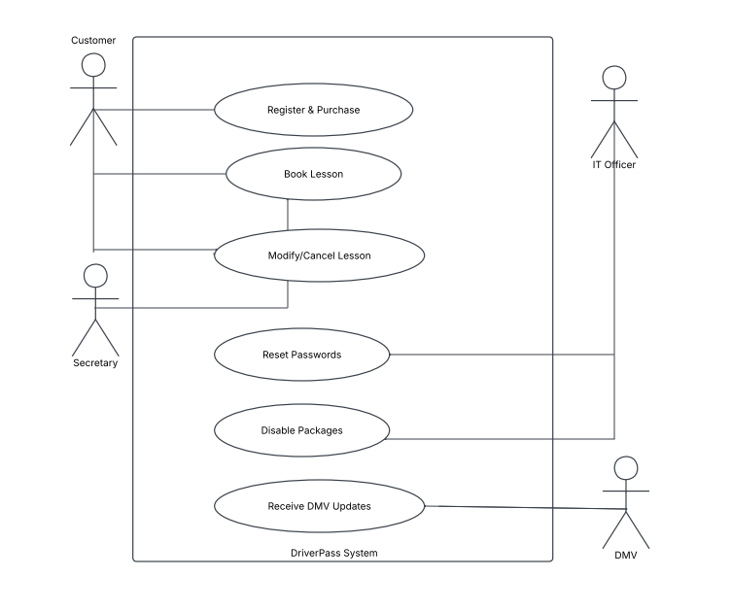

UML Activity Diagrams
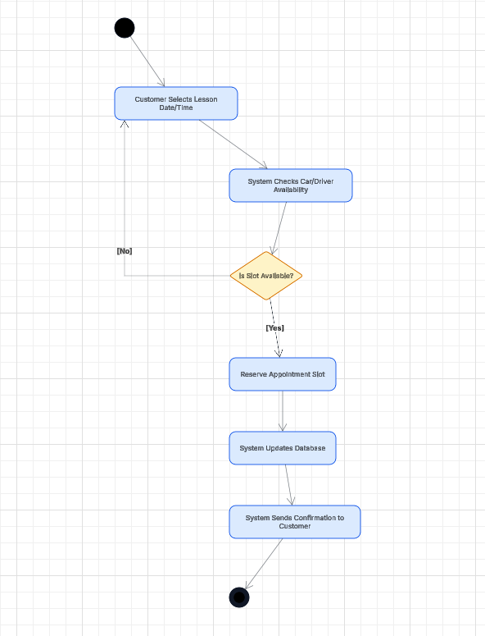

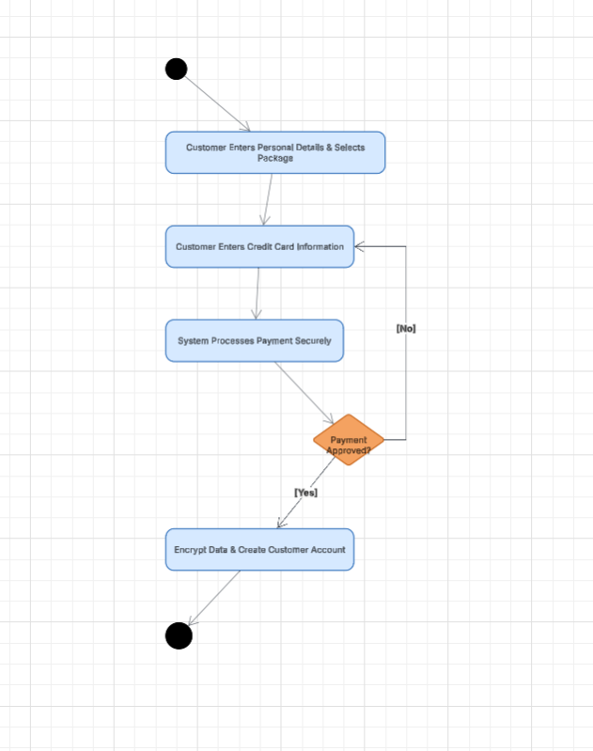

UML Sequence Diagram
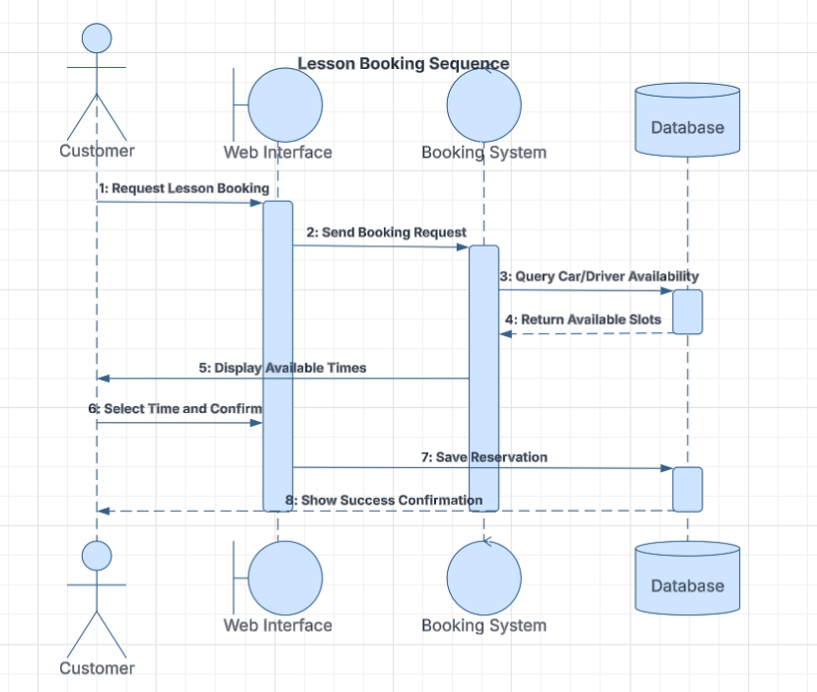

UML Class Diagram
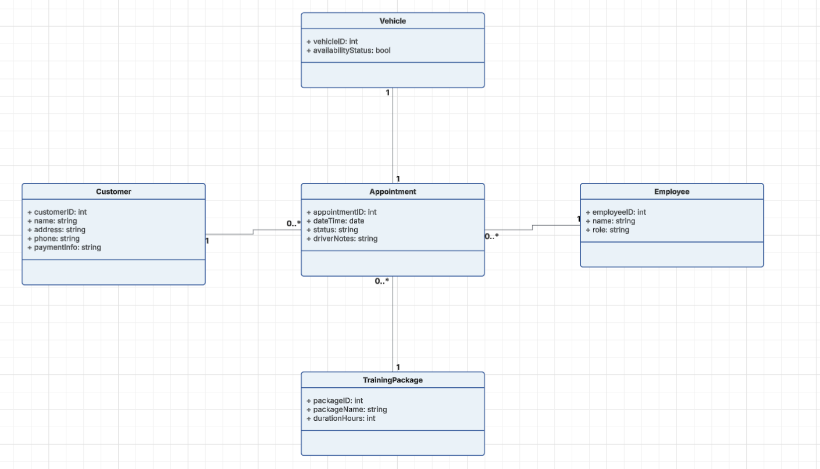

Technical Requirements

Hardware: This will be a setup that will make sure that no hardware is necessary within the premises. DriverPass will not require purchasing and maintaining any physical server. All that the system requires in terms of hardware are simply normal, Internet enabled devices like- (either PCs, Mac, tablet, or phones).

Software: The system needs a more modern cloud based operating platform. The frontend needs to be accessible through web browsers (like Chrome, Safari, Edge) without the need for local apps to run. The backend needs a database management system (like MySQL, PostgreSQL) that will store encrypted customer payments and also scheduling data securely.

Tools: Backup tools need to be automated to make sure that there is no loss of data in case of outages. Also, SSL/TLS encryption tools are important as well, to protect the data transfers from client browsers to the cloud servers especially during checkout times.

Infrastructure: The main infrastructure will consist of a Cloud Hosting environment which pretty much guarantees 99.9% uptime and allows Liam to view reports at home even when students are taking quizzes. The need for a secure data feed with the infrastructure of the local DMV is necessary and also important for real time updates.

